**Chip in the Fields**

**Workshop on Circuits and Systems**

**Panel: Perspective of Insertion of Brazilian Design Houses in the Global Market**

The panel brings new and well-established Brazilian IC Design Houses to discuss perspectives for the Brazilian Market and of insertion in the Global Market. Also looking at important aspects such as human resources, supply chain, governmental regulations, IC design tools, etc.

**Moderator: José Eduardo Bertuzzo - Eldorado Institute**

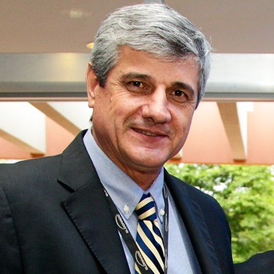J.E.Bertuzzo – Eldorado Institute Technical Operation Senior Executive Director. Electrical Engineering, graduated in 1983 at UNICAMP. Since then involved in R&D project, with international experience in several IBM Corporation R&D Labs in USA and Europe. Join Eldorado Institute in 2004, responsible to implement Eldorado´s IC and Hardware Design area

**Participants**

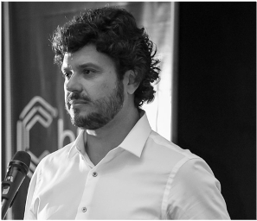**Murilo Pilon Pessatti** is co-founder, CEO and Chief of the Board of Directors of Chipus Microeletrônica S.A. since its inception back to 2008. Chipus is an analog and mixed-signal semiconductor design house company focused on developing leading chips for new markets including sensors and optical communications. He has 20 years of experience in analog and mixed-signal integrated circuit (IC) design and team management. Prior to founding Chipus, He worked for CEITEC SA, Brazil, from 2006-2008, leading and managing a group of 13 analog IC designers working in chips for a passive RFID products line. He also worked for ChipIdea (acquired by Synopsys in 2009) from 2003-2006 as an analog IP designer in the power management group, developing power management unit IPs for top IDM companies, key blocks used inside smartphones, MP3 players and a plethora of portable devices with the function to manage the battery power of these devices efficiently. He has a MBA in project management for technology companies from Pontifícia Universidade Católica do Rio Grande do Sul (PUC-RS), Brazil, in 2009, a Master of Science in Electrical Engineer (MSEE) with emphasis in Microelectronics and Photonics from State University of Campinas (UNICAMP) Brazil, in 2002, and a degree in Electrical Engineer (BSEE), with emphasis in Electronics, from São Paulo University (USP), Brazil, in 2000.

**Julio Leão** – EnSilica Brazil Design Centre Director

Post-doctorate at U.C. Berkeley (USA/2001), PhD. at IMEC/K.U.L. (Belgium/1999), MsC. in Computer Science and BS in Electrical Engineering at UFRGS (Brazil/1989 and 1986)

Worked at Get2chip and Forte (both acquired by Cadence) in the USA, and NSCAD (CI Brasil Program) and Ceitec in Brazil.

Roles include project management, digital design methodologies from RTL to GDSII, EDA software development, digital IC design, technical specifications definition, feasibility analysis, systems and technologies adoption.

**Mustafa Badaroglu** - Dr. Mustafa Badaroglu is Principal Engineer and Architect at Qualcomm responsible from technology and architecture development for products employing Compute-In-Memory Technology. Before rejoining Qualcomm, he previously worked at Huawei, Qualcomm, IMEC, ON Semiconductor, and Tubitak Space. During his career he had various assignments for the execution and management of mobile, server, and automotive chipset designs from concept to volume production, process technology pathfinding, electronic design automation, and design-technology co-optimization. Dr. Badaroglu received his Ph.D. in Electrical Engineering and holds a Master of Industrial Management, both from the Catholic University of Leuven. He holds more than 60 published patents and (co)-authored over 100 publications in scientific journals/proceedings. He is the global chair of IRDS More Moore Team focusing on HVM roadmap of logic devices and memory. He is a senior member of IEEE.

**César Dueñas** received his BSEE from the Federal University of Engineering of Itajubá (UNIFEI) and his MSEE from the Virginia Polytechnic Institute and State University (VA Tech). With over 30 years of experience in the semiconductor industry, he developed his career in the city of Campinas, SP, starting in 1990 as an IC Designer and EDA administrator at Vértice Sistemas Integrados, SiD Microeletrônica's design center in Campinas, working in several gate-array and standard-cell projects for consumer and automotive markets. In 1995 he started at Hitech Electronics Industrial and Commercial (representative of Mentor Graphics) as a resident Applications Engineer at CPqD, providing support and training in CI and PCB design tools. In 1997, he was one of the founders of the Brazil Semiconductor Technology Center (BSTC) of Motorola/Freescale/NXP Semiconductors, starting as IC Designer and EDA Administrator, and then serving in various managerial positions until becoming the R&D Director and Country Manager of the of NXP Brazil in 2018; during this period he participated in the development of dozens of microcontrollers and application processors for the industrial, automotive and more recently, ultra-low power IoT applications. He is currently Director of Technology at HCL Tech, responsible for the semiconductor design services division in Brazil.

**Júlio Oliveira** - Idea! Electronic Systems.

R&D executive and team leader with history of innovation, building technology ecosystems to achieve high technology goals at optical communications field. Bachelor, Electrical Eng., 2003, UFCG-Brazil; Master, Electrical Eng. (Photonics), UNICAMP-Brazil, 2004, and Ph.D, UNICAMP-Brazil, Electrical Eng. (Photonics), 2007. From 2004 to 2014 took, researcher and general manager positions at optical communications systems and photonics devices divisions at CPqD Foundation. Founder and CEO of BrPhotonics, a high-tech startup with accelerated growth in optical communications area developing high end products, LASERs, Modulators, ASICs. Founder of PI-TEC Product Technologies, 2017, and JCRFO Technical Consultancy, 2017, and actual CEO at Idea Electronic Systems, companies acting at high end telecom and Datacom markets, developing deep submicron ASICs and highly integrated photonics devices. Over 18 years of experience in optical communications field, lead 12 optical communications R&D projects (more than USD50M budget), producing 15 patents (INPI), 140+ papers and 20 technological products currently in optical communications market. Entrepreneur of the Year by the Unicamp Innovation Agency in 2020 and Winner of the CBMM Science and Technology 2021 award - in the Technology category - recognized as a professional who has considered relevant to the country in the development of practical applications.

** James Guzzo** is the Vice President of Silicon Engineer at Impinj responsible for the silicon development and productization of impinj’s Endpoint IC and Reader IC product lines. Before joining Impinj he spent 27 years with Intel corporation and had the opportunity to help bring 14 different semi-conductor products to market including the 486 processor, the Pentium2, Itanium, and 8 generations of Xeon® server microprocessor products.  James was the Senior Director of Central Engineering for Intel’s server division and led the development of Intel’s latest Xeon microprocessor prior to joining Impinj.